Git Hands-on 2: Using .gitignore to Ignore Unwanted Files
Objective
Create and verify a .gitignore file that prevents Git from tracking .log files and any log/ directory.

1. Prerequisites
- Git installed and configured.
- Local repository at C:\Users\choll\GitDemo (repo root).
- Work done in Git Bash.

2. Full Command List (run from repo root /c/Users/choll/GitDemo)
Navigate & Verify Repo Root
cd /c/Users/choll/GitDemo
pwd
ls -a
git rev-parse --show-toplevel
git branch --show-current
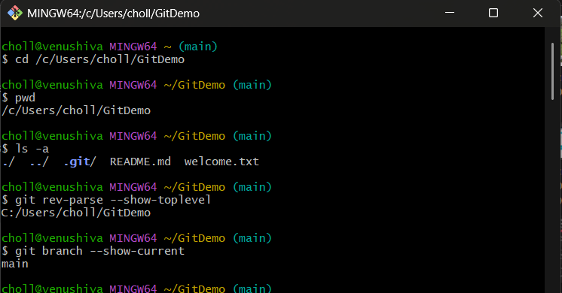

Create Initial Test Files (to demonstrate ignoring)
echo "Test log entry" > debug.log
mkdir -p log
echo "Log inside folder" > log/system.log
git status
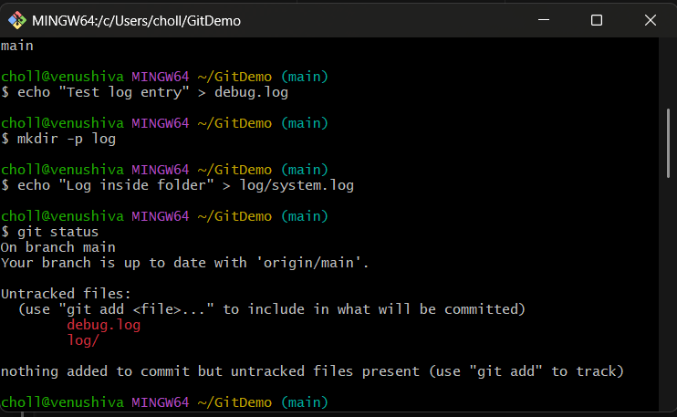

Create .gitignore
Option A (shell):
printf "*.log\nlog/\n" > .gitignore
Verify:
cat .gitignore
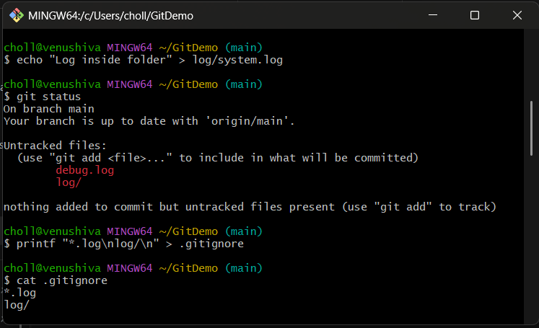

Re-check Status After Adding .gitignore
git status
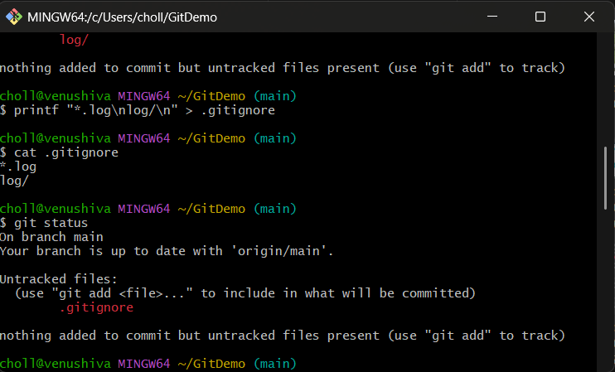

If Logs Were Previously Tracked (untrack but keep files locally)
Check whether files are tracked:
git ls-files | grep -E '(^|/)debug.log$|(^|/)log/' || echo "not tracked"
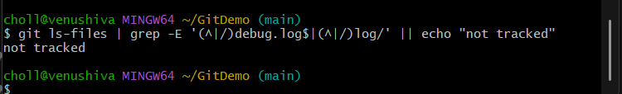

git rm --cached debug.log
git rm -r --cached log
git status
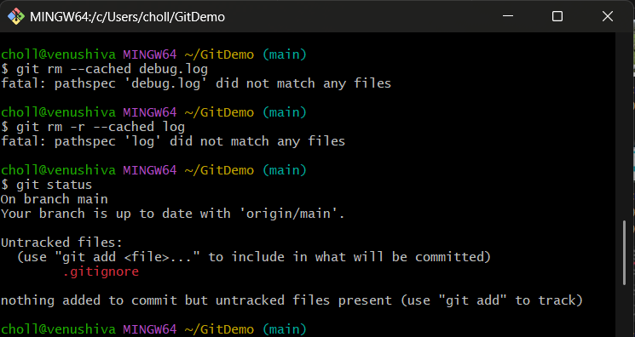

Stage & Commit .gitignore
git add .gitignore
git commit -m "Add .gitignore to ignore .log files and log folder"
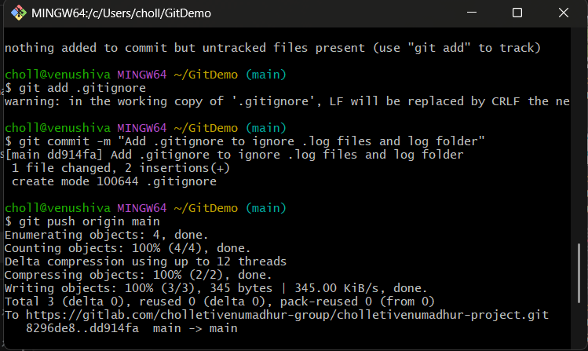

Verify Ignore Rule with a New Test File
echo "new test" > another.log
git status
